Web Based Database Management Systems Project

Garo Tawidian 104576654

April 7th, 2021

1. Introduction……………………………………………………………………2

2. Features of Application………………………………………………………..3

3. Tools & Techniques…………………………………………………………...4

4. Implementation Details………………………………………………………..5

5. Conclusion…………………………………………………………………….7

6. References…………………………………………………………………….7

Introduction

Welcome to The Computer Place (<http://pacek.myweb.cs.uwindsor.ca/comp3077/project/html/products.html>). This project aims at creating an ecommerce website that sells computer parts such as headphones, CPUs, and keyboards. It is designed to be able to be easy to traverse through the site with utmost simplicity. The design of the site is based off the content offered so there is a theme to match the content respectfully and in a neat fashion in a way it is easy to understand as well as appeal to the consumer.

Features of Application

Customers can browse the site, choose a product, and buy it using a purchase form. They can also contact us through a contact form on a separate page. Finally, the website contains an about us page offering information about the company’s history and goals.

Tools & Techniques

The website was made using different web development tools and languages such as html, CSS, JavaScript and php. The main, static page was created with html and CSS, the form validation script uses JavaScript and php was used to send form data to the database.

Implementation Details

The website template was first created with html, by making a header with navigation, a main section for specific content, and a footer with a thank you message along with the contact page. This template was used throughout the website.

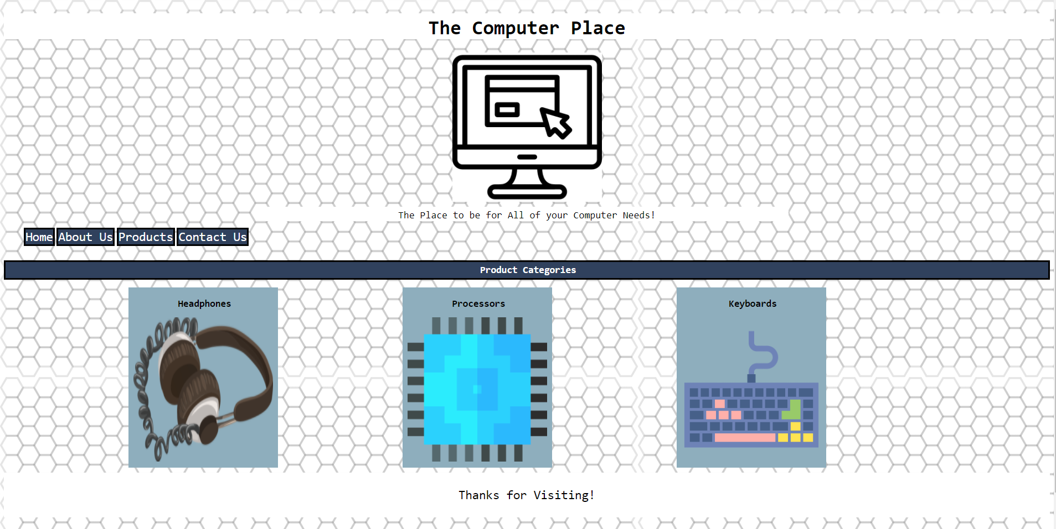

Next the main sections were created with a category-based index page showing the different types of products sold. If one of these categories is clicked, the user is brought to a page with category-specific products with their details and a buy button.

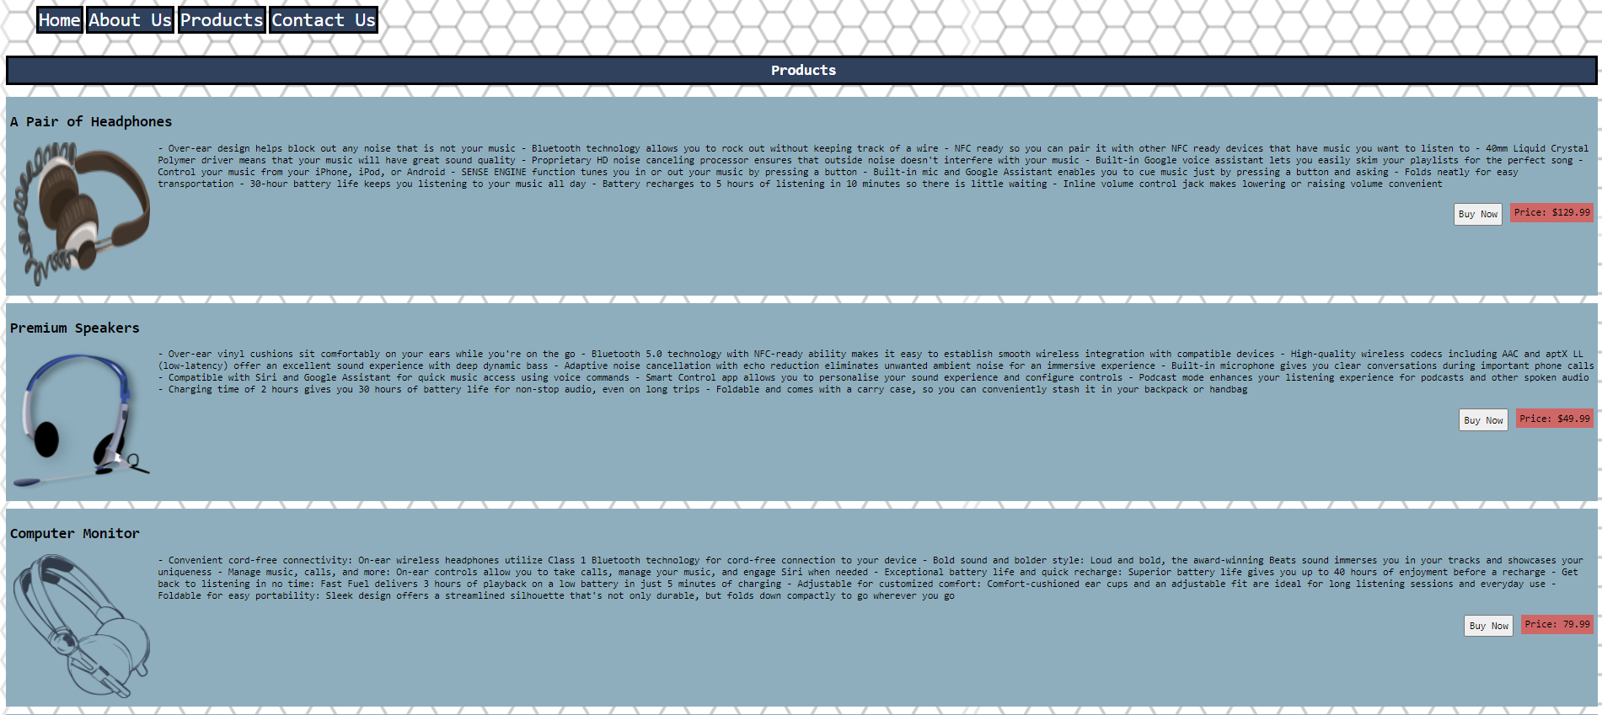

If the buy button is clicked, the user is brought to a purchase form page where they fill out their information to purchase their product. Once this form is submitted, the information gets sent to the database, and the user is given a thank you message.

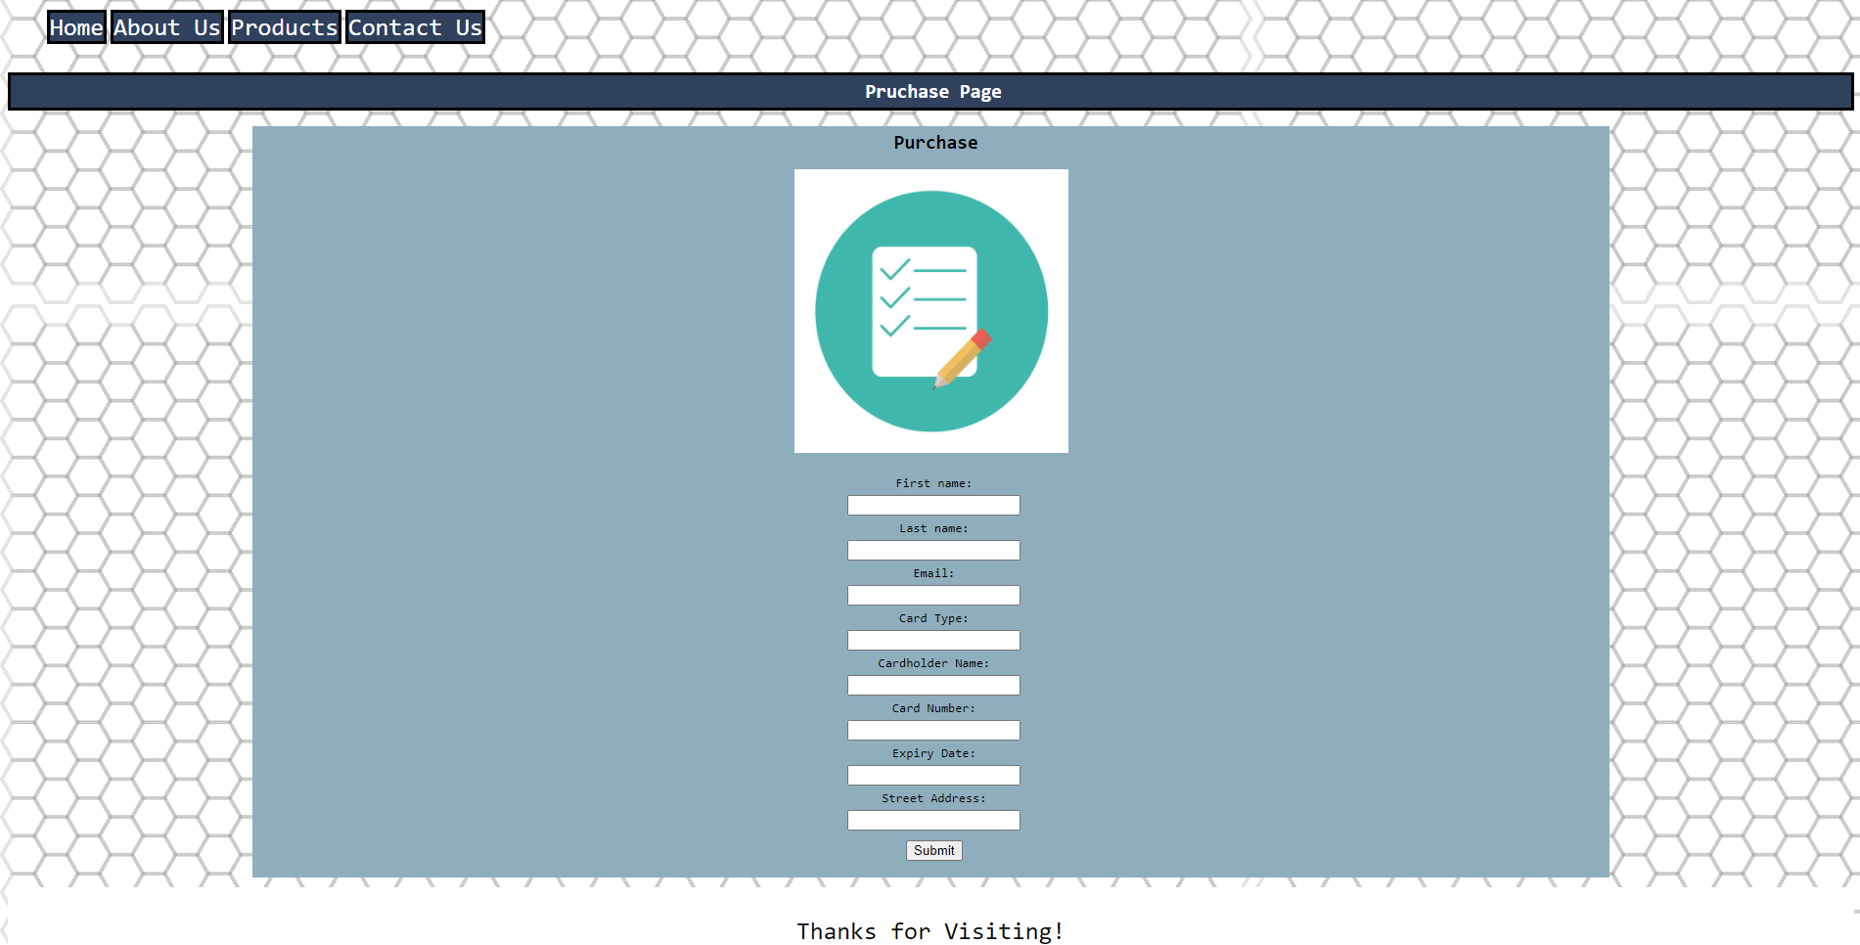

The thank you message displayed after purchase as well as a link to allow the users to head back to the site. A similar page is displayed when you send a message through the contact us page.

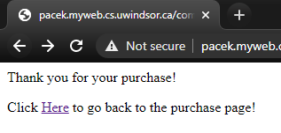



Here are the data bases for each webpage receiving the information that is entered.

PURCHASE PAGE

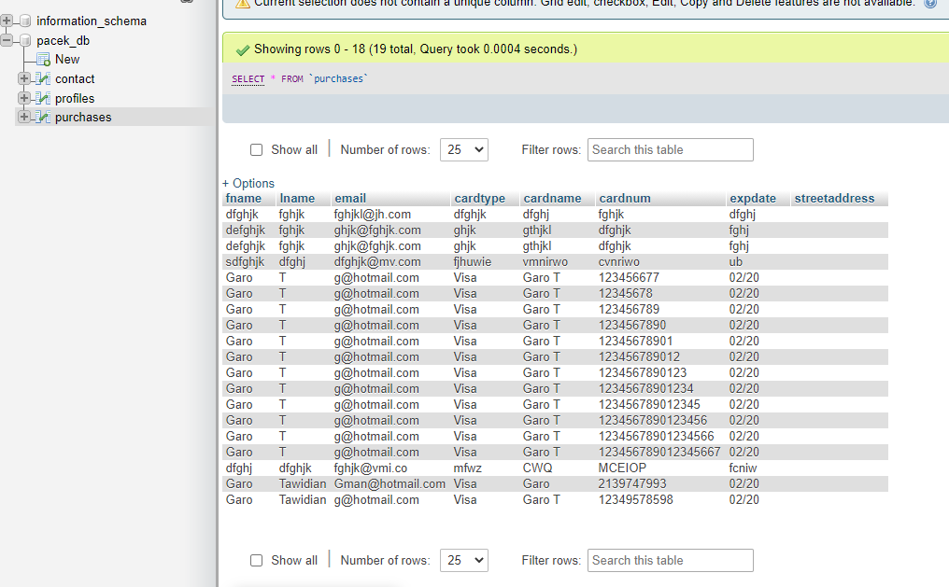

CONTACT US FORM

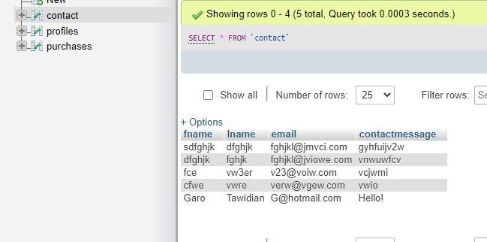

Conclusion

This ecommerce website was created to sell computer parts and utilizes tools and techniques common in the web development industry. In the future, we would like to implement the details of connecting the card data to an actual vendor to complete a purchase.

References:

<https://www.w3schools.com/>

Lecture Notes and Slides